







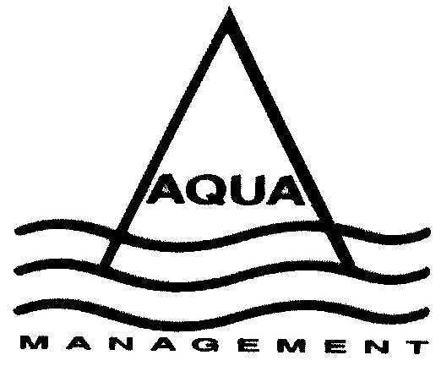

Children of all abilities welcome
Kiwisport
FUN WEEK

DATES: WEEK 1
Monday 17th January to Friday 21st January 2022

Time 9.00am – 4.00pm daily

WHERE:

Centralines Stadium and Pool

AGE:
5-12 years

COST:

$8.00 per child for half day

$15.00 per child for whole day

Registration Forms and Payment should be dropped off at:

Centralines Sports Complex Pool Reception

Pre-registration and payments essential
 | NOTE PROGRAM ACTIVITIES MAY ALTER DUE TO COVID RESTRICTIONS
Time | MONDAY 17TH | TUESDAY 18TH | WEDNESDAY 19TH | THURSDAY 20TH | FRIDAY 21ST
9:00am | Welcome!  Warm Up  &  Group Games | Warm Up  &  Group Games | Warm Up  &  Games | Warm Up  &  Games | Warm Up  &  Games
9:30am | Multi-Sport  Games | Waka Tākaro  (Toy Trailer) | Volleyball | Basketball  Arts & Craft | Turf Time  Rock Painting
10:15am | MORNING TEA
10.45 am | Turf time  Capture the Flag | Obstacle Course  Races &  Team Building  Activities | Turf time  Arts & Craft | Biscuit  Decorating  & Activities | Group Games  Obstacle Course
12:00pm | LUNCH
1:00pm | Swimming | Swimming | Swimming | Swimming | Swimming
3-4.00pm | Group Games  Wind down | Group Games  Wind down | Group Games  Wind down | Group Games  Wind down | Group Games  Wind down


REGISTRATION FORM WEEK 1
Week of: Monday 17th January 2022
Name:
Address:
Age: Male/ Female
Phone: Cellphone: D.O.B:
Email address:
Emergency Contacts
No 1 Name: Surname:
Relationship: Phone: Cell Phone:
No 2 Name: Surname:
Relationship: Phone: Cell Phone:

My Child will attend these days: Depending on weather some games maybe outside

M T W T F
Am Am Am Am Am
Pm Pm Pm Pm Pm

Health Details:
Family Doctor:
Name of people authorised to pick up my child(ren):
Name: Phone:
Name: Phone:
I give permission for my child to leave the program unsupervised signed:

You may be eligible for a Winz Subsidy

Waiver
I, parent/caregiver hereby agree to my child partaking in the week’s activities. I accept that Aqua Management will not be liable for any harm or injury that my child/children may incur, but understand that they will endeavour to provide a safe, positive environment where risks are minimised and quality experiences are maximised.

Signed:
Payment enclosed: Date:

Aqua Management maintain accurate records in accordance with the Privacy Act 1993 and other relevant legislation. No information is shared except with the owner’s permission or as required by authorised staff, legislation or statutory agencies.

Fair Play Promise for
Kiwisport
FUN WEEK

Good sport is about a positive attitude
Play your part – Play fair

What to bring with you:

Check list:

- A Drink Bottle
- Appropriate Footwear
- Togs and Towel
- A healthy lunch and snacks
- Warm Clothing
- Sun Hats
- Big Smiley Faces

*Please make sure to dress warm as the stadium can be cold.

On Behalf of the Aqua Management Team, we hope that you come and enjoy the Holiday Program with us.



